FOR IMMEDIATE RELEASE
August 25, 2020

Read Better Be Better Gifted 1,500 Summer Bundles from Arizona Central in Collaboration with USA Today, the Ford Motor Company Fund, and the Smithsonian Institute

PHOENIX, AZ. – A Phoenix-based 501(c)(3), Read Better Be Better (RBBB), was gifted 1,500 summer bundles—Arizona Central newspapers and Smithsonian Summer Road Trip At-Home K-8 activity guides—from Arizona Central in collaboration with USA Today, the Ford Motor Company Fund, and the Smithsonian Institute for inclusion in the nonprofit’s Family Literacy Kits.
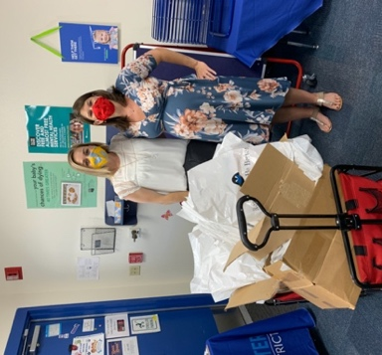
To prevent reading regression during the COVID-19 global pandemic, RBBB created and distributed their Family Literacy Kits to all 2nd and 3rd graders at partner schools this spring as part of their new Family Literacy Program. Further, this summer Read Better Be Better was able to host distribution days throughout July and August, distributing kits to 16 local organizations and many local families. Overall, RBBB has been able to distribute 5,208 Family Literacy Kits to 16 organizations and 54 schools in 11 districts since May of 2020.
Figure 1: Teachers receive a wagon full of RBBB Family Literacy Kits.

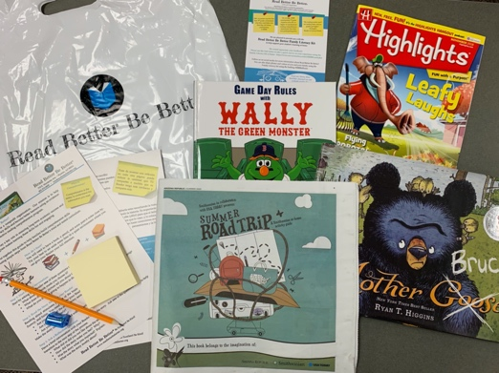
Partnerships like the ones formed between RBBB and AZ Central are critical in times of economic hardship and adversity. With the donation of these summer bundles, RBBB was able to create more kits, allowing educational achievement to continue, youth development and empowerment to increase, interpersonal connections between caregivers and children to develop, and alleviating the stress put onto caregivers during this time of isolation.

The RBBB Family Literacy Kits created with the AZ Central donations contain a curriculum guide, a reading resource sheet, storybooks, a Highlights magazine, an AZ Central newspaper, a Smithsonian Summer Road Trip at-home 40-page activity guide full of bilingual activities, puzzles, and games, sticky notes, and a pencil and sharpener. The RBBB curriculum guide provides clear instructions to help caregivers assist their children in gaining reading comprehension skills and can be used with any available reading material in the home or from the kit.
Figure 2: The contents of a RBBB Family Literacy Kit created with AZ Central donations.

Read Better Be Better is grateful for the community partners that support our mission to improve literacy skills in the state of Arizona. If you would like to learn more or participate in the Family Literacy Program, visit https://www.readbetterbebetter.org/family-literacy-program/ or email program@readbetterbebetter.org.

RBBB was founded as a response to Arizona’s literacy crisis; the state is ranked 45th in the nation for childhood literacy and 48th for PreK-12 education. Currently, 69% of 3rd graders from low-income families in Arizona do not read at grade level, and students who do not read proficiently by the end of 3rd grade are four times less likely to graduate from high school. With proper reading intervention, there is an 89% chance that students who can read at grade level by the end of 3rd grade will graduate from high school, irrespective of socio-economic status.

For more information about Read Better Be Better, visit www.readbetterbebetter.org.

###

